PRACTICAL DBMS
NAME: B.Poorvaja
REG.NO:192473008
COURSE CODE: CSA0503
COURSE NAME: DATABASE MANAGEMENT SYSTEMS
EXPERIMENT NO:1 DDL Commands – CREATE, ALTER, DROP
AIM:
To Create, Alter, Drop, Rename, Truncate using Data Definition Language (DDL) statements.
Description:
Data Definition Language (DDL) statements are used to define the database structure or schema.
DDL Commands: Create, Alter, Drop, Rename, Truncate
➢ CREATE - to create objects in the database
➢ ALTER - alters the structure of the database
➢ DROP - delete objects from the database
➢ TRUNCATE - remove all records from a table, including all spaces allocated for the records are
removed
➢ RENAME - rename an object
SYNTAX:
CREATE TABLE
CREATE TABLE table_name
(
column_name1 data_type,
column_name2 data_type,
column_name3 data_type,
....
);
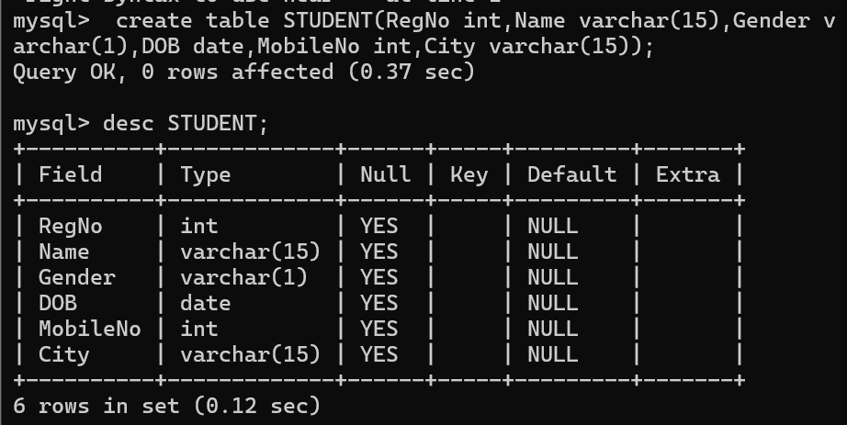
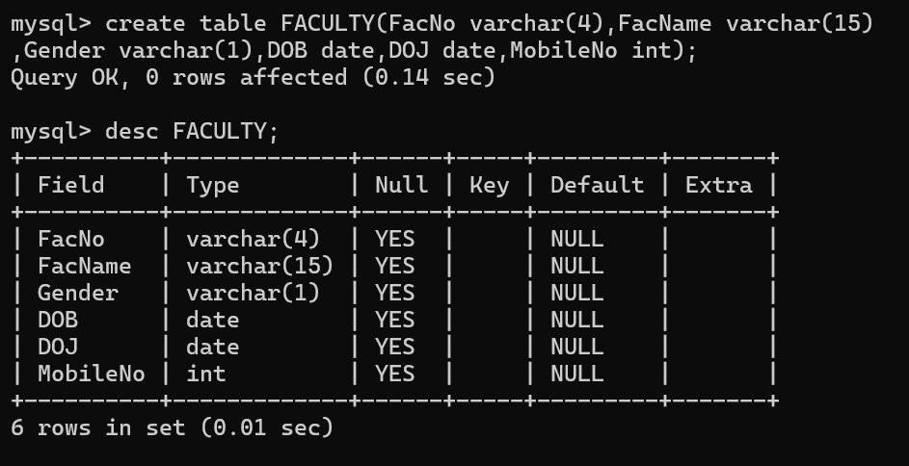
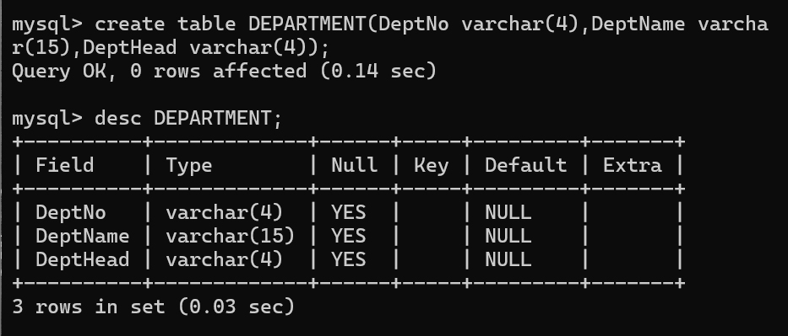
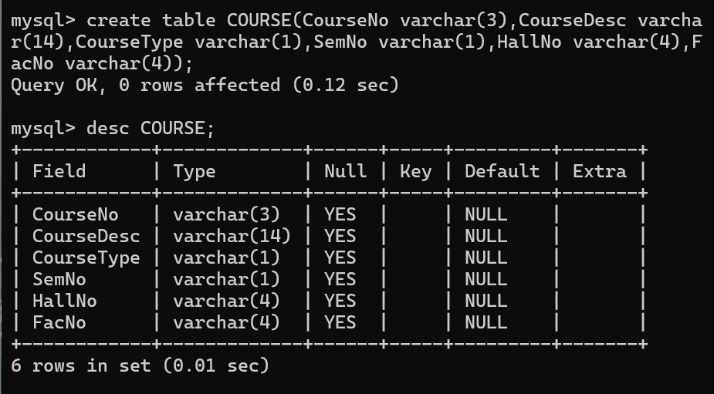

ALTER A TABLE
To add a column in a table
ALTER TABLE table_name
ADD column_namedatatype;

To delete a column in a table
ALTER TABLE table_name
DROP COLUMN column_name;
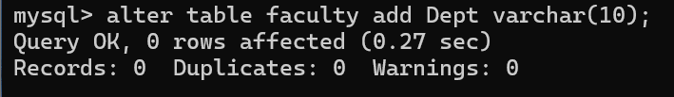
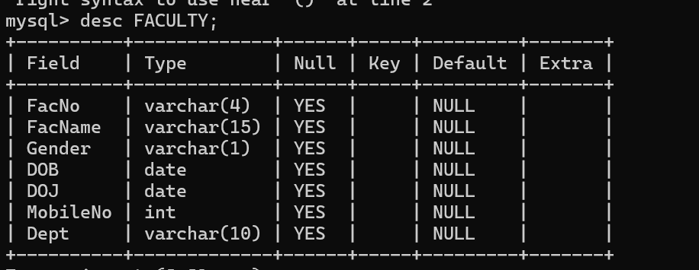

DROP TABLE
DROP TABLE table_name;
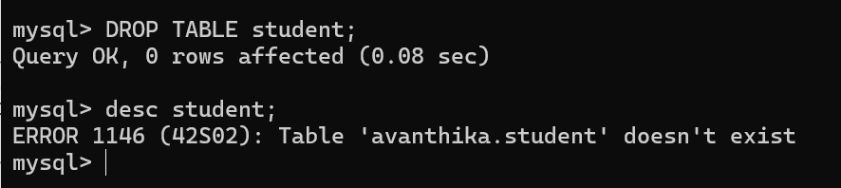

TRUNCATE TABLE
TRUNCATE TABLE table_name;

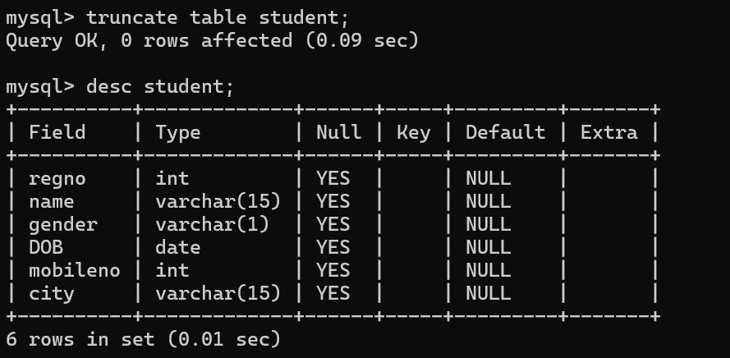
RESULT:
Tables are created, altered and modified using DDL commands.

